7.20: As in Example 7.8, 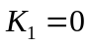 and 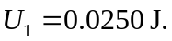 For 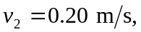 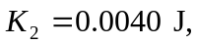 so 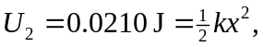 so 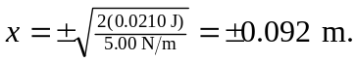 In the absence of friction, the glider will go through the equilibrium position and pass through 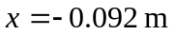 with the same speed, on the opposite side of the equilibrium position.

